**Atmospheric CO2 and ocean acidity**

What prior knowledge do you already have about the levels of carbon dioxide in the atmosphere?

CO2 is essential to life on Earth. Although CO2 occupies only about 0.04% of the total mass of the atmosphere, this concentration is sufficient to sustain life.

Study the following three equations below which have been proposed to occur in the environment:

Equation 1: CO2(g) ⇌ CO2(aq)

Equation 2: CO2(aq) + H2O(ℓ) ⇌ H2CO3(aq)

Equation 3: H2CO3(aq) ⇌ HCO3-(aq) + H+(aq)

*(Recall that H2CO3 is carbonic acid, a weak acid that partially ionises in solution to form H+)*

Using your knowledge of **chemical equilibrium**, predict how increasing levels of atmospheric CO2 will affect the three equilibrium reactions.

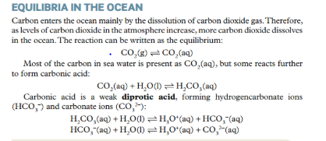

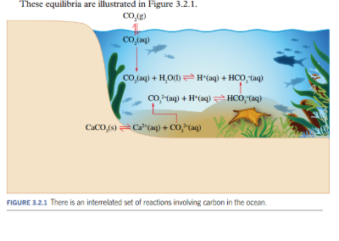

Write a hypothesis relating atmospheric CO2 levels and pH of surrounding water in contact with the CO2.

____________________________________________________________________________________________________________________________________________________________________

**Ocean acidification is the decrease in pH that is occurring due to the absorption of CO2 from the atmosphere.**

CO2 gas , as with other gases, is more soluble in cold water. As a result, ocean acidification is greater in the polar regions.

**Carbonate equilibria**

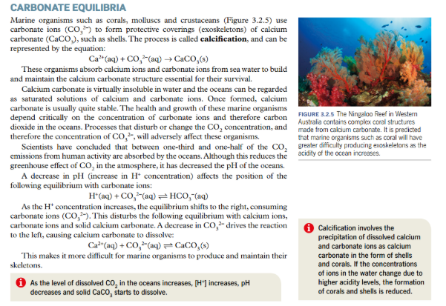

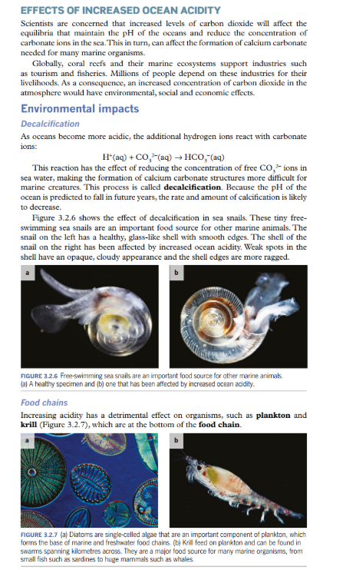

Krill eggs will not hatch successfully at a lower pH. Increased ocean acidity have a harmful effect on the species of plankton and krill as other species depend for their survival. A collapse of krill population along with ocean warming would have a disastrous effect on the ecosystem of the ocean.

**Social and economic impacts**

Increased ocean acidity will have social and economic impacts, particularly people in coastal communities. Increased ocean acidity will potentially affectfood supplies, coastal protection and tourism.